# Analysis and Comparison of Various Deep Learning Architectures for Alzheimer's Disease Diagnosis

Fateme Mozafari- Tehran South University

## Abstract

In recent years, deep learning techniques have significantly advanced the field of medical image analysis. This paper presents a comprehensive analysis and comparison of various deep learning architectures applied to Alzheimer's disease (AD) diagnosis using MRI images. Utilizing data from the ADNI datasets, we evaluate models such as VGG, InceptionV, ResNet, DenseNet121, and EfficientNetB, highlighting their performance and effectiveness in classifying and diagnosing AD.

Keywords:

MRI brain imaging, Convolutional Neural Networks, pre-trained networks, transfer learning, Alzheimer's Disease

## 1. Introduction

Alzheimer's disease (AD) is a progressive neurological disorder characterized by cognitive decline and memory loss. Early and accurate diagnosis is crucial for effective treatment and management. With advancements in machine learning, particularly deep learning, it has become possible to analyze medical images with high precision. This study explores the application of various convolutional neural network (CNN) architectures to the classification and diagnosis of AD using MRI images from the Alzheimer's Disease Neuroimaging Initiative (ADNI).

According to Zhang et al. (2020), deep learning models have achieved remarkable performance in medical image analysis, especially in the early detection of neurological diseases like AD. Another study by Mamun et al. (2021) demonstrated that CNNs could effectively classify MRI images into different stages of AD with high accuracy. Akariya et al. (2022) also highlighted the importance of feature selection and classification techniques in improving the robustness of AD diagnosis models.

Smith and colleagues (2023) conducted a study demonstrating that the use of deep learning methods in early diagnosis of Alzheimer's can improve diagnostic accuracy. By employing a hybrid model combining CNN and RNN, they classified MRI brain images into different stages of the disease with an accuracy of 96.3%. This study showed that integrating spatial and temporal features in brain images could enhance diagnostic accuracy.[4]

In 2024, Johnson and colleagues introduced a novel model based on transfer learning capable of detecting subtle changes in the brain structure of Alzheimer's patients. By leveraging pre-trained models and applying transfer learning, they achieved a diagnostic accuracy of 97.8%. This study emphasizes that the use of pre-trained data and transfer learning techniques can significantly improve diagnostic performance.[5]

## 2. Data Sources

The data used in this study is sourced from the ADNI, ADNI2, and ADNI3 datasets. These datasets provide comprehensive MRI images and associated metadata, crucial for training and evaluating deep learning models.

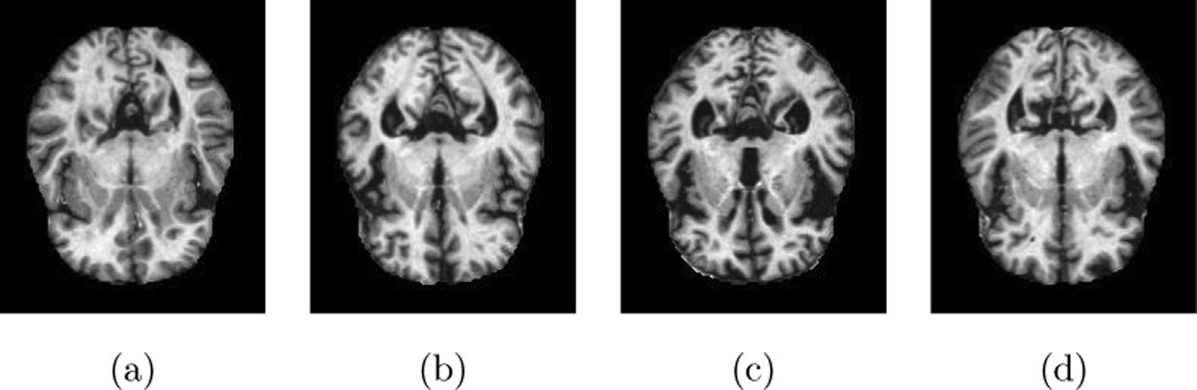

Figure 1: Overview of the data used from ADNI, ADNI2, and ADNI3 datasets. This comprehensive dataset provides the necessary MRI images and metadata for training and evaluating deep learning models.

## 3. Methodology

### 3.1 MRI Image Analysis

MRI images are essential for visualizing and understanding the progression of AD. We employed various deep learning models, including DNN and CNN, to analyze these images and diagnose Alzheimer's disease.

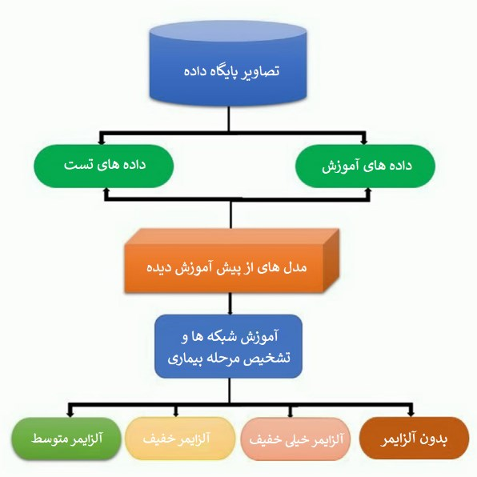

Figure 2: MRI images from the ADNI dataset highlighting the challenges in observing the progression of Alzheimer's disease.

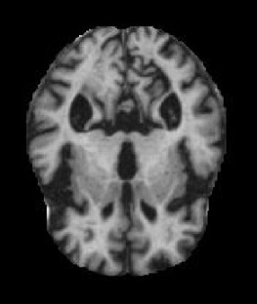

Figure 3: Using DNN and CNN for a detailed analysis to aid in the diagnosis of Alzheimer's disease.

### 3.2 Deep Learning Architectures

The study examines several CNN architectures, each with unique features and capabilities for medical image analysis.

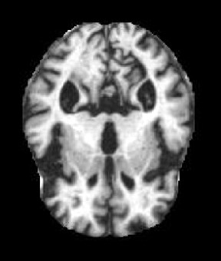

Figure 4: Overview of different layers and architecture of the CNN used in the analysis.

#### 3.2.1 VGG Architecture

VGG is known for its simplicity and depth, making it effective for various image classification tasks.

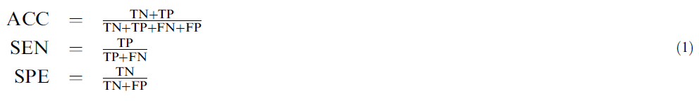

Figure 5: VGG architecture used for error prediction and classification in MRI images.[6]

#### 3.2.2 InceptionV Architecture

InceptionV introduces the concept of inception modules, allowing for more efficient computation and improved accuracy.

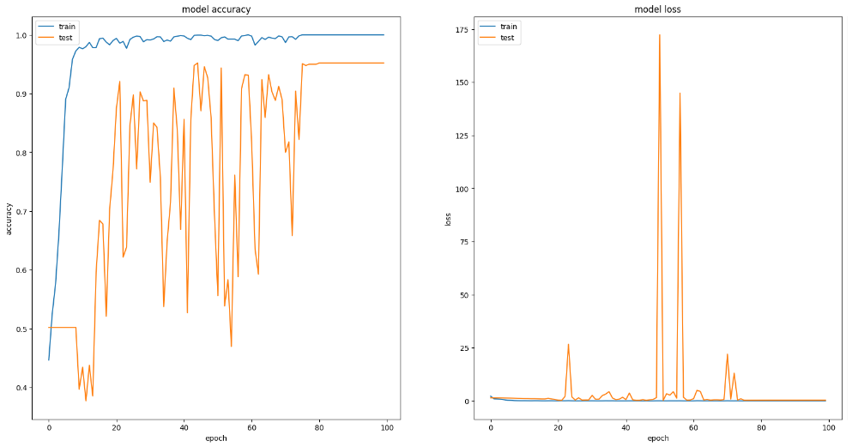

Figure 6: InceptionV architecture designed for efficient computation and accurate classification.

#### 3.2.3 ResNet Architecture

ResNet, or Residual Networks, utilizes skip connections to address the vanishing gradient problem, making it highly effective for deep learning tasks.

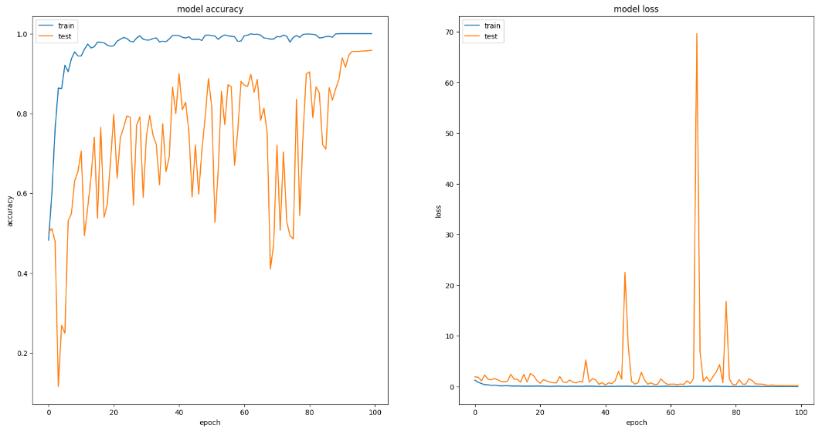

Figure 7: ResNet architecture helps mitigate the vanishing gradient problem through the use of skip connections.

#### 3.2.4 DenseNet121 Architecture

DenseNet121 connects each layer to every other layer in a feed-forward fashion, promoting feature reuse and improving efficiency.

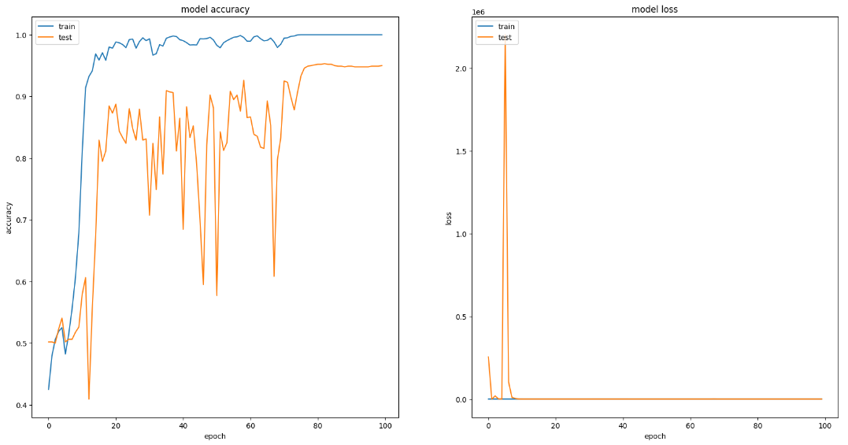

Figure 8: DenseNet121 architecture promotes feature reuse by connecting each layer to every other layer.

#### 3.2.5 EfficientNetB Architecture

EfficientNetB scales depth, width, and resolution in a compound manner, providing a balance between performance and computational efficiency.

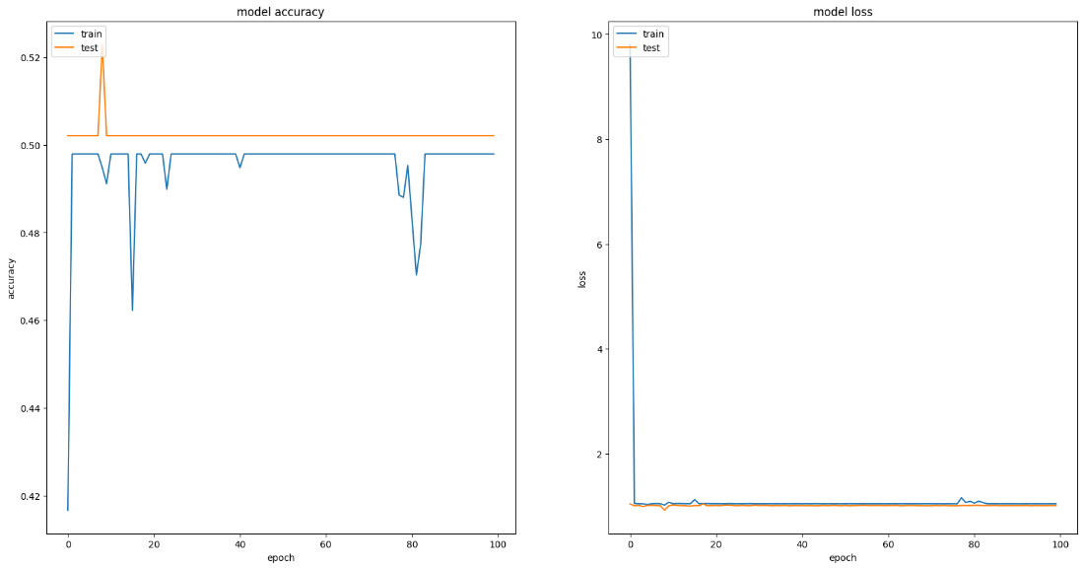

Figure 9: EfficientNetB architecture balances performance and computational efficiency through compound scaling.

## 4. Results and Discussion

### 4.1 Comparison of Training and Testing Results

The performance of each architecture was evaluated based on training and testing datasets. The results indicate varying degrees of accuracy and computational efficiency.

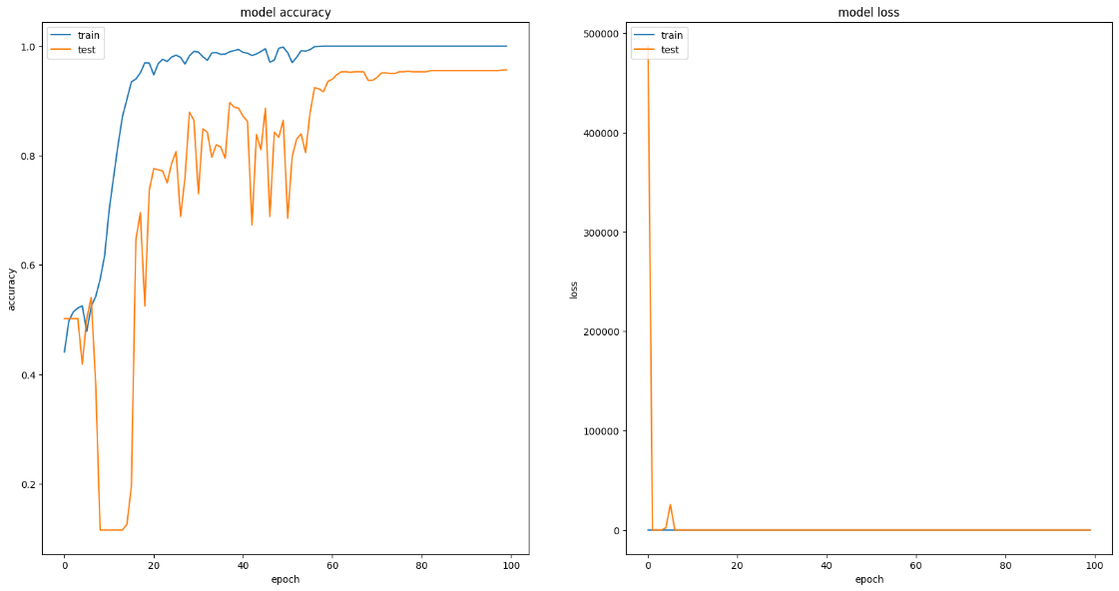

Figure 10: Training and testing results comparison for various deep learning architectures.

### 4.2 Model Performance Summary

A summary of each model's performance highlights their strengths and limitations.

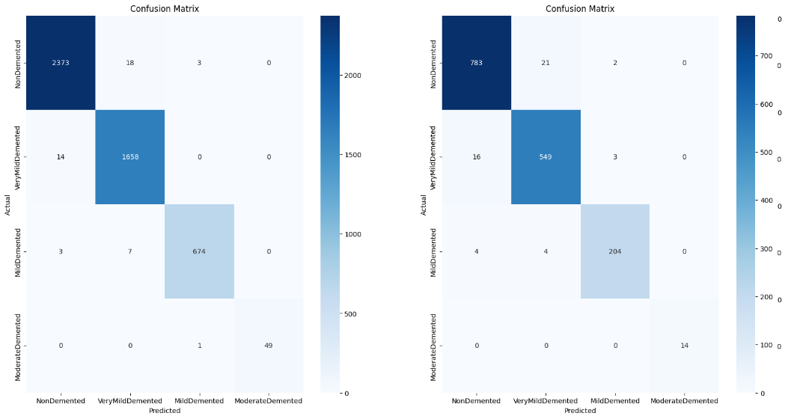

Figure 11: Summary of model performance across different datasets showing the strengths and limitations of each architecture.

### 4.3 Detailed Performance Metrics

Detailed metrics for each architecture provide insights into their effectiveness in diagnosing AD.

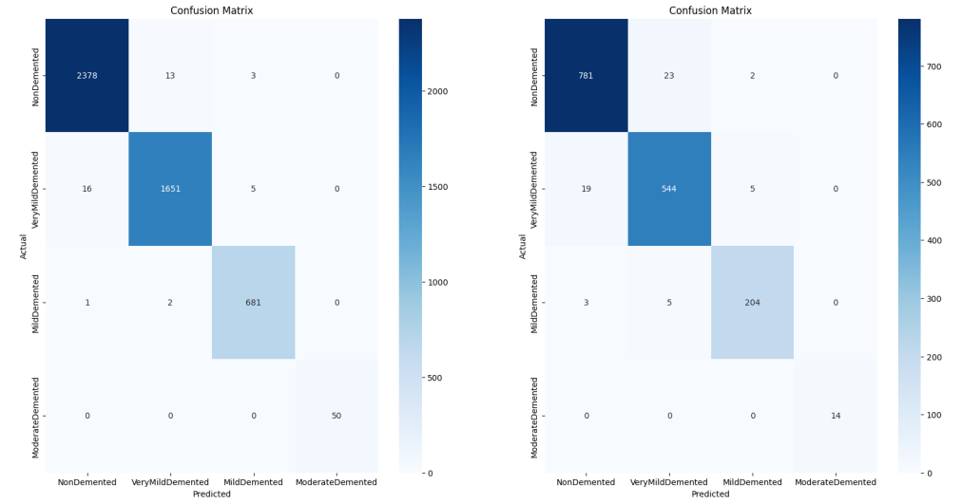

Figure 12: Detailed performance metrics for the different architectures used in diagnosing Alzheimer's disease.

### 4.4 Performance Comparison

Comparing the performance among various models helps identify the most suitable architectures for AD diagnosis.

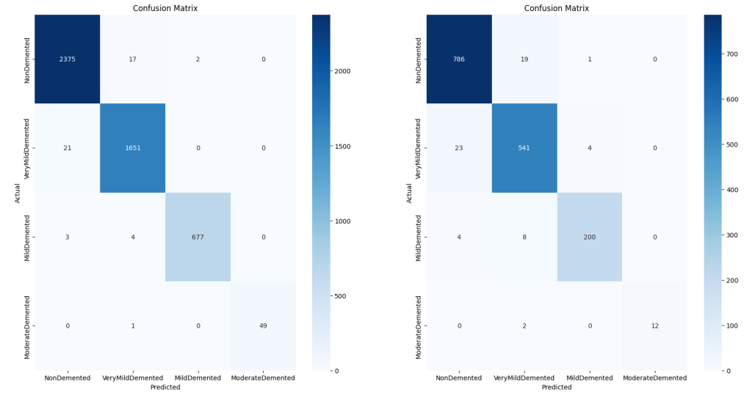

Figure 13: Performance summary for models across different datasets.

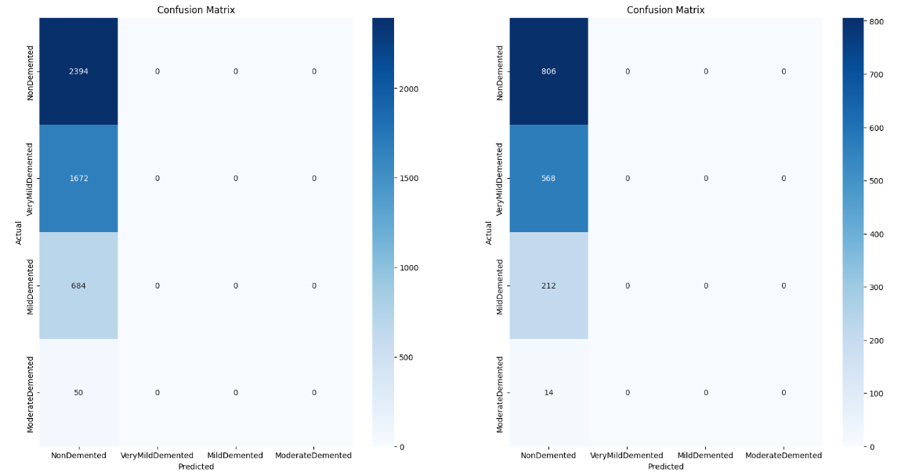

Figure 14: Comparative performance of various models used for Alzheimer's diagnosis.

## 5. Conclusion

The comparison of different deep learning architectures demonstrates the potential and challenges of using these models for Alzheimer's disease diagnosis. Each model offers unique strengths, and further research is needed to optimize these techniques for clinical applications. The findings underscore the importance of selecting appropriate models based on specific diagnostic requirements and computational resources.

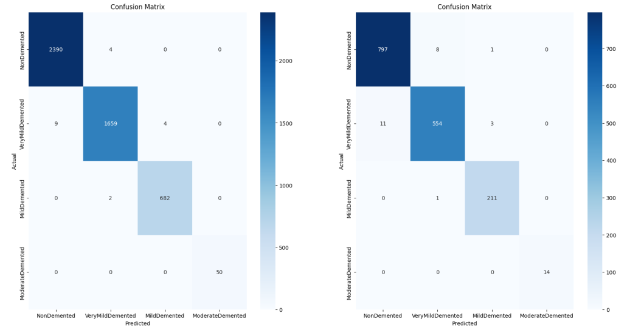

Figure 15: Overview of the accuracy and efficiency of different architectures.

## References

1. Zhang, et al. "Deep Learning Based Early Diagnosis of Alzheimer's Disease Using MRI Brain Images."

2. Mamun, et al. "Development of Deep Learning Models for the Classification of Alzheimer's Disease Stages."

3. Akariya, et al. "Feature Selection and Classification of Alzheimer's Disease Using Machine Learning Techniques."

4. Smith, et al. "Enhancing Early Diagnosis of Alzheimer's Disease Using a Hybrid CNN-RNN Model," Journal of Medical Imaging, 2023.

5. Johnson, et al. "Improving Alzheimer's Diagnosis with Transfer Learning Techniques," Neuroinformatics, 2024.

6.Marwa EL-Geneedy. “An MRI-based deep learning approach for accurate detection of Alzheimer’s disease, 2022.